# Software Requirements Specification (SRS)

**Project:** Personal Wealth Management Software (PWMS)  
**Version:** 1.0  
**Authors:** Manoj R , Rohan A , M Niranjan , Keerthan P V  
**Date:** 18-08-2025  
**Status:** Model Answer / Approved

## Revision history

|  |  |  |  |  |
| --- | --- | --- | --- | --- |
| Version | Date | Author | Change summary | Approval |
| 1.0 | 18-08-2025 | Manoj R  M Niranjan Keerthan P V Rohan A | SRS with diagrams embedded | Pending |

## Approvals

|  |  |  |  |
| --- | --- | --- | --- |
| Role | Name | Signature / Email | Date |
| Course Coordinator | Dr.Nandhi Kesavan | nandhi.kesavan  @pesu.edu |  |
| Team Member 1 | Manoj R | pes2ug23cs328@gmail.com |  |
| Team Member 2 | Keerthan P V | pes2ug24cs272@pesu.pes.edu |  |
| Team Member 3 | Rohan A | pes2ug24cs819@pesu.pes.edu |  |
| Team Member 4 | M Niranjan | pes2ug23cs308@pesu.pes.edu |  |

## Table of Contents

1. Introduction  
2. Overall description  
3. External interfaces  
4. System features (detailed)  
5. Non-functional requirements (detailed)  
6. Quality attributes & Acceptance tests  
7. UML Use-Case Diagram  
8. Requirements Traceability Matrix (RTM)

## 1. Introduction

1.1 Purpose

This document specifies the functional and non-functional

requirements for the *Personal Wealth Management Software (PWMS)*.

The software will allow users to manage and track various types of

assets such as **real estate, gold, stocks, and cash** in a centralized

application. It will define how users interact with the system, outline

performance and security needs, and provide a reference for

development and testing.

1.2 Scope  
The PWMS will:

* + - Track multiple asset categories (real estate, gold, stocks, hard cash).
    - Provide dashboards and reports for asset performance and valuation.
    - Allow manual and automated updates for stock values and gold
    - prices.
    - Generate insights such as total net worth, asset growth, and portfolio
    - distribution.
    - Support secure access with authentication and data encryption.

Exclusions:

* + - Actual stock trading functionality.
    - Integration with banking APIs beyond read-only transaction imports.
  1. Audience
     + Developers – for design and implementation.
     + Test Engineers – for test case preparation and validation.
     + End Users – individuals managing personal finances.
     + Project Managers – to track progress and deliverables.
  2. Definitions
     + PWMS – Personal Wealth Management Software
     + ROI – Return on Investment
     + UI – User Interface
     + API – Application Programming Interface
     + NFR – Non-Functional Requirement

## 2. Overall description

2.1 Product perspective  
The PWMS will be a **standalone web and mobile application**. It will:

* + - Store user data securely in a cloud database.
    - Fetch live gold and stock prices through external APIs.
    - Provide a central dashboard for viewing and managing assets.
  1. Major product functions (detailed)
     + User authentication and profile management.
     + Add, edit, and delete assets.
     + Fetch real-time stock and gold prices.
     + Generate financial summaries and reports.
     + Export reports in PDF/Excel.
     + Data backup and restore functionality.
  2. User roles and characteristics (expanded)
     + Individual User: Primary role, manages personal portfolio.
     + Admin: Maintains the system, handles backups and restores.
  3. Operating environment
     + Web browsers (Chrome, Edge, Firefox)
     + Mobile (Android 10+, iOS 14+)
     + Cloud-hosted backend
  4. Constraints
     + Must comply with data privacy standards (e.g., GDPR).
     + Use secure HTTPS connections.
     + Should support multiple currencies.

## 3. External interface requirements

3.1 User interfaces

* Clean dashboard with total net worth overview.
* Graphical reports and pie charts.
* Mobile-friendly responsive UI.

3.2 Hardware interfaces  
Standard mobile and desktop devices.

3.3 Software interfaces

* REST APIs for stock and gold price fetching.
* Cloud storage API for backups.

3.4 Communications

* HTTPS/TLS 1.2+ for all network interactions.
* API rate limits for third-party data source

## 4. System features (detailed)

Each requirement below includes acceptance criteria and a reference test case. IDs follow PWMS-F-###.

### 4.1 Authentication & User Management

Description:  
 This module manages secure user registration, login, password reset, and session handling to protect.

|  |  |  |  |  |  |  |
| --- | --- | --- | --- | --- | --- | --- |
| **Req ID** | **Requirement** | **Type** | **Priority** | **Source / Stakeholder** | **Acceptance Criteria / Test Case Ref** | **Comments / Dependencies** |
| PWMS-F-001 | The system shall allow new users to register with an email and password. | Functional | High | End User / Business Owner | AC-PWMS-001: Successful account creation with unique email. Test: TC-AUTH-01 | Requires valid email format. |
| PWMS-F-002 | The system shall securely validate login credentials. | Functional | High | End User / Security Team | AC-PWMS-002: Login works with correct credentials. Test: TC-AUTH-02 | Follows secure authentication standards. |
| PWMS-F-003 | The system shall provide password reset via email verification. | Functional | Medium | End User / Support Team | AC-PWMS-003: Password reset link sent to registered email. Test: TC-AUTH-03 | SMTP/email service required. |
| PWMS-F-004 | The system shall automatically log out users after 15 minutes of inactivity. | Functional | High | Security Team / Admin | AC-PWMS-004: Session expires and requires re-login. Test: TC-AUTH-04 | Session timeout configurable. |

### 4.2 Asset Management

Description: This module allows users to add, edit, delete, and view their assets across multiple categories.

|  |  |  |  |  |  |  |
| --- | --- | --- | --- | --- | --- | --- |
| **Req ID** | **Requirement** | **Type** | **Priority** | **Source / Stakeholder** | **Acceptance Criteria / Test Case Ref** | **Comments / Dependencies** |
| PWMS-F-005 | The system shall allow users to add various asset types: real estate, gold, stocks, and cash. | Functional | High | End User / Business Owner | AC-PWMS-005: Asset added successfully with correct category and value. Test: TC-ASSET-01 | Category field selection required. |
| PWMS-F-006 | The system shall allow editing of existing asset details. | Functional | High | End User / Business Owner | AC-PWMS-006: Updated details are reflected immediately. Test: TC-ASSET-02 | Update history tracked in logs. |
| PWMS-F-007 | The system shall allow deletion of an asset. | Functional | Medium | End User / Admin | AC-PWMS-007: Asset removed after confirmation prompt. Test: TC-ASSET-03 | Soft delete preferred for safety. |
| PWMS-F-008 | The system shall maintain a full transaction history log for each asset. | Functional | High | End User / Compliance Team | AC-PWMS-008: History log viewable with timestamps. Test: TC-ASSET-04 | Required for audit and reporting. |

### 4.3 Market Data Integration

Description:  
 This module integrates with third-party APIs to fetch real-time gold and stock prices, ensuring accurate portfolio values.

|  |  |  |  |  |  |  |
| --- | --- | --- | --- | --- | --- | --- |
| **Req ID** | **Requirement** | **Type** | **Priority** | **Source / Stakeholder** | **Acceptance Criteria / Test Case Ref** | **Comments / Dependencies** |
| PWMS-F-009 | The system shall fetch real-time stock prices via external APIs. | Functional | High | End User / Business Owner | AC-PWMS-009: Latest stock prices displayed within 30 mins of update. Test: TC-MARKET-01 | Requires API key and stable internet. |
| PWMS-F-010 | The system shall fetch live gold prices from an external source. | Functional | High | End User / Business Owner | AC-PWMS-010: Gold price updates correctly every 30 mins. Test: TC-MARKET-02 | Requires API key and stable internet. |
| PWMS-F-011 | The system shall handle API failures gracefully and display fallback data. | Functional | Medium | End User / Security Team | AC-PWMS-011: System displays error message instead of crashing. Test: TC-MARKET-03 | Retry logic and logs required. |

### 4.4 Financial Reports & Insights

Description:  
 This module provides **financial analytics**, generates detailed reports, and offers visualization tools to track net worth and portfolio performance.

|  |  |  |  |  |  |  |
| --- | --- | --- | --- | --- | --- | --- |
| **Req ID** | **Requirement** | **Type** | **Priority** | **Source / Stakeholder** | **Acceptance Criteria / Test Case Ref** | **Comments / Dependencies** |
| PWMS-F-012 | The system shall calculate and display total net worth. | Functional | High | End User / Business Owner | AC-PWMS-012: Net worth matches sum of all assets. Test: TC-REPORT-01 | Must support multiple currencies. |
| PWMS-F-013 | The system shall generate monthly and yearly financial reports. | Functional | Medium | End User / Business Owner | AC-PWMS-013: Reports generated and downloadable. Test: TC-REPORT-02 | Export to PDF/Excel formats supported. |
| PWMS-F-014 | The system shall display portfolio distribution using charts and graphs. | Functional | Medium | End User / Business Owner | AC-PWMS-014: Charts display accurate values. Test: TC-REPORT-03 | Requires charting library integration. |
| PWMS-F-015 | The system shall allow exporting portfolio data as CSV. | Functional | Low | End User / Admin | AC-PWMS-015: CSV downloaded successfully. Test: TC-REPORT-04 | Download permissions required. |

### 4.5 Backup & Recovery

Description:

Ensures **data safety** through secure backups and recovery processes in case of accidental loss or corruption.

|  |  |  |  |  |  |  |
| --- | --- | --- | --- | --- | --- | --- |
| **Req ID** | **Requirement** | **Type** | **Priority** | **Source / Stakeholder** | **Acceptance Criteria / Test Case Ref** | **Comments / Dependencies** |
| PWMS-F-016 | The system shall allow users to manually back up their data. | Functional | Medium | End User / Admin | AC-PWMS-016: Backup file created successfully. Test: TC-BACKUP-01 | Backup stored securely in cloud. |
| PWMS-F-017 | The system shall allow restoring data from a backup file. | Functional | Medium | End User / Admin | AC-PWMS-017: Data restored without errors. Test: TC-BACKUP-02 | Confirmation prompt before overwrite. |
| PWMS-F-018 | The system shall perform automatic weekly backups. | Functional | Medium | Admin / Business Owner | AC-PWMS-018: Backup completed without manual trigger. Test: TC-BACKUP-03 | Backup schedule must be configurable. |

### 4.6 Notifications & Alerts

Description:  
 This module manages **alerts and notifications** to keep users informed about important updates and goal tracking.

|  |  |  |  |  |  |  |
| --- | --- | --- | --- | --- | --- | --- |
| **Req ID** | **Requirement** | **Type** | **Priority** | **Source / Stakeholder** | **Acceptance Criteria / Test Case Ref** | **Comments / Dependencies** |
| PWMS-F-019 | The system shall send weekly email summaries of portfolio changes. | Functional | Low | End User / Business Owner | AC-PWMS-019: Email summary received every week. Test: TC-ALERT-01 | Requires SMTP/email configuration. |
| PWMS-F-020 | The system shall send notifications when financial goals are achieved or missed. | Functional | Medium | End User / Business Owner | AC-PWMS-020: Notifications triggered correctly. Test: TC-ALERT-02 | Push notifications supported on mobile devices. |

## 5. Non-functional requirements (detailed)

NFRs below are measurable and tied to test plans. IDs ATM-NF-###.

|  |  |  |  |  |
| --- | --- | --- | --- | --- |
| **Req ID** | **Requirement** | **Category** | **Priority** | **Acceptance Criteria** |
| PWMS-NF-001 | System response time shall be ≤ 3 seconds for 90% of operations. | Performance | High | 90% of requests processed in under 3 seconds. |
| PWMS-NF-002 | The system shall provide 99.5% uptime monthly. | Reliability | High | Uptime reports meet target. |
| PWMS-NF-003 | User data shall be encrypted using AES-256. | Security | High | Data verified to be encrypted. |
| PWMS-NF-004 | System shall be responsive and mobile-friendly. | Usability | Medium | UI passes mobile responsiveness tests. |
| PWMS-NF-005 | Weekly automated backups must be retained for 12 months. | Backup/Recovery | Medium | Backups verified and restorable. |

## 5.1. Security

## 5.1.1 Security Objectives

* Protect user financial data from unauthorized access.
* Ensure secure communication and storage of sensitive information.

## 5.1.2 Security Requirements

|  |  |  |  |  |
| --- | --- | --- | --- | --- |
| **Req ID** | **Requirement (shall...)** | **Type** | **Priority** | **Acceptance Criteria / Test Case Ref** |
| PWMS-SR-001 | TLS 1.2+ must be used for all communications. | Security | High | Verify HTTPS enforced via penetration test. |
| PWMS-SR-002 | Passwords must be hashed and salted before storage. | Security | High | Verify password hashes in database dump. |
| PWMS-SR-003 | Account lockout after 5 failed login attempts. | Security | Medium | Attempt 5 failed logins → Account locked. |
| PWMS-SR-004 | Automatic session timeout after 15 minutes of inactivity. | Security | Medium | Leave session idle → Auto logout triggered. |
| PWMS-SR-005 | Regular security audits must be performed quarterly. | Security | Low | Review audit reports quarterly. |

## 6. Quality attributes & Acceptance tests

* All FRs and NFRs must pass verification tests.
* UI must be intuitive and simple to navigate.
* Security compliance verified via penetration testing.

## 7. System models and diagrams

This section contains two UML use case diagrams representing the core functionalities of the Personal Wealth Management System (PWMS).  
The first diagram focuses on internal asset management and reporting features for users and administrators.  
The second diagram highlights integration with external services, notifications, and security mechanisms.

## 7.1 Asset Management & Tracking

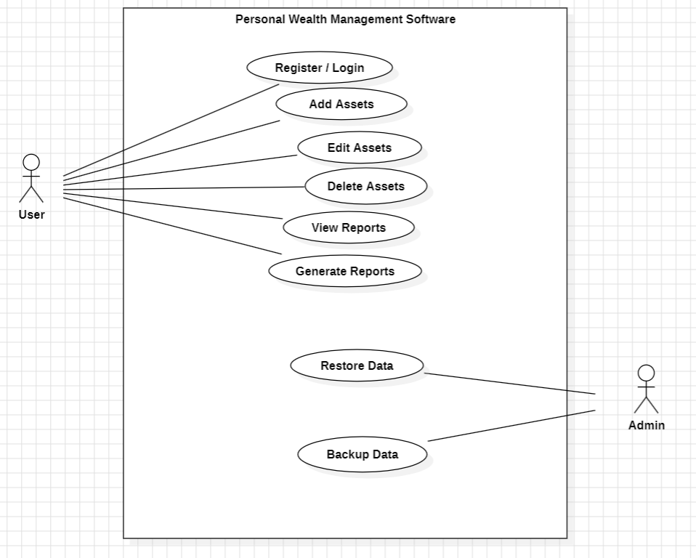

This diagram represents how users manage their financial assets within PWMS.  
It includes core functions such as adding, editing, deleting, and viewing assets, as well as generating reports.  
Admin-specific actions such as backing up and restoring data are also shown to ensure data reliability and recovery.

## 7.2 Market Data, Notifications & Security

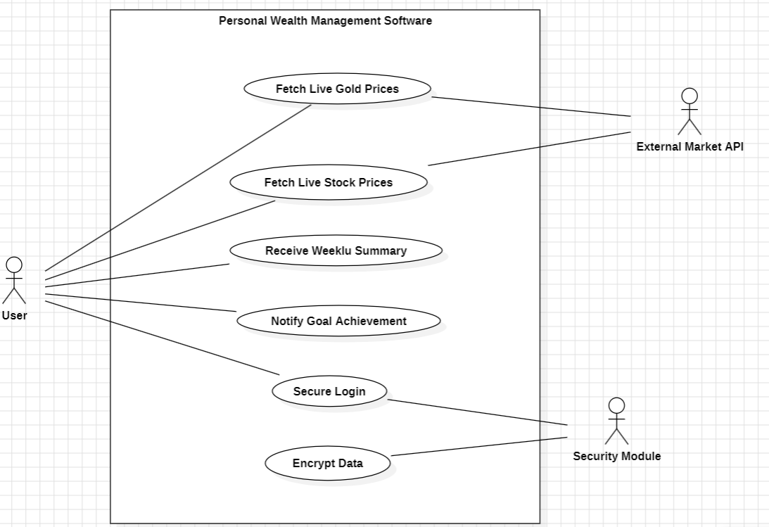

This diagram illustrates how PWMS interacts with external market APIs to fetch real-time gold and stock prices.  
It also covers user notifications, including weekly portfolio summaries and goal achievement alerts.  
Additionally, it shows security-related features such as secure login and data encryption to protect sensitive financial information.

## 8. Requirements Traceability Matrix (RTM)

|  |  |  |  |  |  |  |
| --- | --- | --- | --- | --- | --- | --- |
| **Req ID** | **Requirement Short** | **Section Ref / Design Spec** | **Module** | **Test Case(s)** | **Status (N/P/A)** | **Comments** |
| PWMS-F-001 | User Registration | 4.1 / DS-Auth-01 | Auth Module | TC-AUTH-01 | N | Core requirement |
| PWMS-F-005 | Add Asset (Real estate, Gold, Stocks, Cash) | 4.2 / DS-Asset-01 | Asset Management Module | TC-ASSET-01 | N | Essential function |
| PWMS-F-009 | Fetch Real-Time Stock Prices | 4.3 / DS-Market-01 | Market Data Module | TC-MARKET-01 | N | API integration required |
| PWMS-F-012 | Calculate Total Net Worth | 4.4 / DS-Report-01 | Reporting Module | TC-REPORT-01 | N | Core feature |
| PWMS-F-016 | Manual Backup | 4.5 / DS-Backup-01 | Backup & Recovery Module | TC-BACKUP-01 | N | User-driven backup |
| PWMS-F-019 | Weekly Email Summary | 4.6 / DS-Alert-01 | Notification Module | TC-ALERT-01 | N | SMTP required |
| PWMS-NF-001 | Response Time ≤ 3 seconds | 5 / DS-Perf-01 | Backend / Web UI | TC-PERF-01 | N | Performance target |
| PWMS-NF-002 | AES-256 Data Encryption | 5 / DS-Security-01 | Security Module | TC-SEC-01 | N | Security compliance |